8
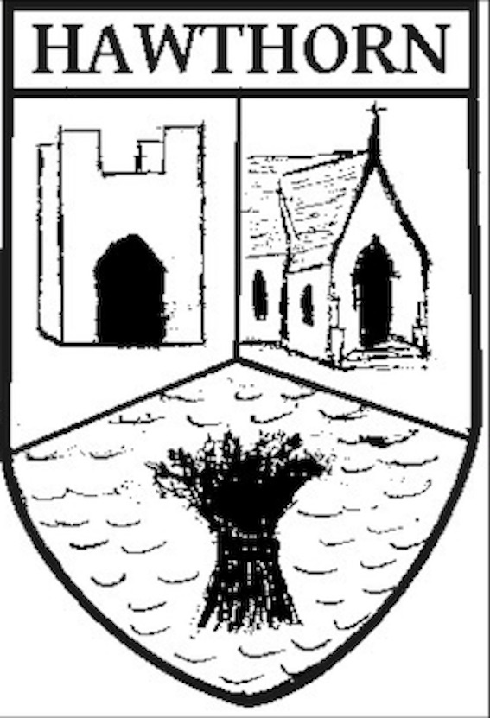 | Hawthorn Parish Council  Clerk to the Council: Mrs Lesley Wilkinson BA(Hons)  64 Rothbury Road, Newton Hall, Durham DH1 5PG  Email: clerk@hawthornparish.co.uk | 

A Meeting of the HAWTHORN PARISH COUNCIL will be held in the Community Centre on

MONDAY 21st September 2026 at 6.15pm

L A Wilkinson

Clerk to the Council

AGENDA

Members of the public are welcome to attend and may ask questions providing that they do so during the Public Participation part of this meeting at Point 7

Apologies for Absence

Declarations of Interest, if any

Presentation from John Ruddick, Principal Development Manager and Katie Culverhouse, Community Relations Manager from Banks Group re plan to submit a hybrid planning application around September for a housing site to the north of the emerging Garden Village.

The Minutes of the last meeting – held on Monday 20th July 2026

Matters of Information

Reports

County Councillor’s Report

Response from County Cllr Rowney

Police Report

Response re Police contact information

Community Centre Report

Parish Website and email addresses

National Joint Council Pay Awards

Public Participation

Correspondence

Planning

Current Planning applications, if any

Finance

Current balance

Village Matters

Date of the Next Meeting – Monday 19th October at 7pm

